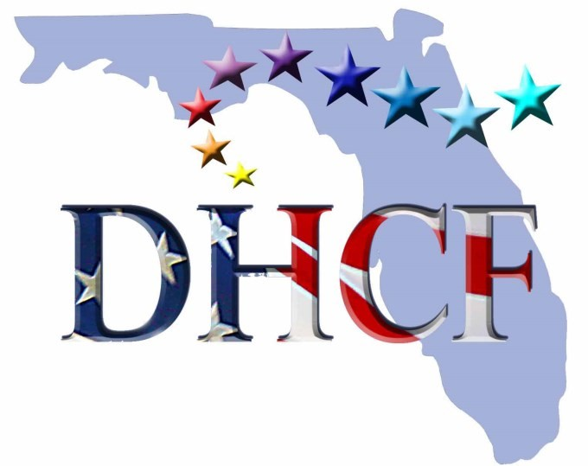
DEMOCRATIC HISPANIC CAUCUS OF FLORIDA

NAME:
ADDRESS:
CITY: ZIP:
COUNTY:
CELL: OTHER# E-MAIL:
I hereby certify that I am a registered Democrat, and will respect all by-laws as set forth by the Democratic Hispanic Caucus of Florida.

Signature: DATE:
Annual Dues: $20.00 - Payable to VCC-DHCF

Method:
CASH CHECK PAYPAL
MAIL TO:
VCC-DHCF
P.O. BOX 5603
DELTONA, FL. 32728
OR
SCAN AND EMAIL SIGNED APPLICATION TO:
VCCDHC@gmail.com
Revised Jan. 16, 2015

